EX NO: 2a | GENERATION AND ANALYSIS OF FREQUENCY MODULATED (FM) SIGNALS USING MATLAB
DATE:

Objective 2: To analyze the frequency spectrum of the generated FM signal using FFT and identify the carrier component, sideband frequencies, and the bandwidth of the FM signal based on Carson's rule

PROGRAM (MATLAB CODE)
% Calculation and Verification of Frequency Deviation
% and Modulation Index of FM Signals
clc;
clear;
close all;
%% Input Parameters
Am = 2; % Message signal amplitude
fm = 500; % Message frequency (Hz)
Ac = 1; % Carrier amplitude
fc = 10000; % Carrier frequency (Hz)
kf = 1000; % Frequency sensitivity (Hz/V)
fs = 100000; % Sampling frequency (Hz)
T = 0.02; % Simulation duration (s)
t = 0:1/fs:T;
%% Message Signal
m = Am*cos(2*pi*fm*t);
%% Frequency Deviation Calculation
delta_f = kf * Am;
%% Modulation Index Calculation
beta = delta_f/fm;
%% FM Signal Generation
fm_signal = Ac*cos(2*pi*fc*t + beta*sin(2*pi*fm*t));
%% Plot Message Signal
figure;
subplot(2,1,1);
plot(t,m,'LineWidth',1.5);
title('Message Signal');
xlabel('Time (s)');
ylabel('Amplitude');
grid on;
%% Plot FM Signal
subplot(2,1,2);
plot(t,fm_signal,'LineWidth',1.5);
title('Frequency Modulated Signal');
xlabel('Time (s)');
ylabel('Amplitude');
grid on;
%% Spectrum Analysis
N = length(fm_signal);
FM_fft = fftshift(abs(fft(fm_signal))/N);
f = (-N/2:N/2-1)*(fs/N);
figure;
plot(f,FM_fft,'LineWidth',1.5);
title('FM Signal Spectrum');
xlabel('Frequency (Hz)');
ylabel('Magnitude');
grid on;
xlim([fc-10000 fc+10000]);
%% Display Results
fprintf('\nFM SIGNAL PARAMETERS\n');
fprintf('---------------------------\n');
fprintf('Carrier Frequency = %.0f Hz\n',fc);
fprintf('Message Frequency = %.0f Hz\n',fm);
fprintf('Message Amplitude = %.2f V\n',Am);
fprintf('Frequency Sensitivity = %.0f Hz/V\n',kf);
fprintf('\nCALCULATED VALUES\n');
fprintf('---------------------------\n');
fprintf('Frequency Deviation (Δf) = %.0f Hz\n',delta_f);
fprintf('Modulation Index (β) = %.2f\n',beta);
%% Carson's Rule Bandwidth
BW = 2*(delta_f + fm);
fprintf('Bandwidth (Carson Rule) = %.0f Hz\n',BW);

Procedure
- Open MATLAB and create a new script file.
- Clear the command window, workspace variables, and close all existing figure windows using:
clc;
Clear;
close all;
- Define the message signal parameters:
- Message amplitude Am=2V
- Message frequency fm=500Hz
- Define the carrier signal parameters:
- Carrier amplitude Ac=1V
- Carrier frequency fc=10000Hz
- Set the frequency sensitivity constant kf=1000Hz/V, sampling frequency fs=100000Hz, and simulation duration T=0.02s.
- Generate the time vector using:
t = 0:1/fs:T;
- Generate the message signal using:
m = Am*cos(2*pi*fm*t);
- Calculate the frequency deviation of the FM signal using:
Δf=kf.Am
- Calculate the modulation index using:
β=Δf/f_m
- Generate the FM signal using:
fm_signal = Ac*cos(2*pi*fc*t + beta*sin(2*pi*fm*t));
- Plot the message signal in the time domain and observe its waveform.
- Plot the generated FM signal and observe that the carrier frequency varies according to the message signal while the amplitude remains constant.
- Determine the length of the FM signal:
N = length(fm_signal);
- Compute the Fast Fourier Transform (FFT) of the FM signal:
FM_fft = fft(fm_signal);
- Shift the spectrum to center the zero-frequency component and normalize it:
FM_fft = fftshift(abs(FM_fft)/N);
- Generate the frequency axis corresponding to the FFT output:
f = (-N/2:N/2-1)*(fs/N);
- Plot the frequency spectrum of the FM signal and observe the carrier component and sidebands.
- Restrict the frequency axis around the carrier frequency for better visualization:
xlim([fc-10000 fc+10000]);
- Calculate the bandwidth of the FM signal using Carson's Rule:
BW=2(Δf+f_m)
- Display the carrier frequency, message frequency, frequency deviation, modulation index, and bandwidth in the MATLAB command window.
- Execute the program and verify that the calculated frequency deviation and modulation index match the values used in generating the FM signal

OUTPUT:
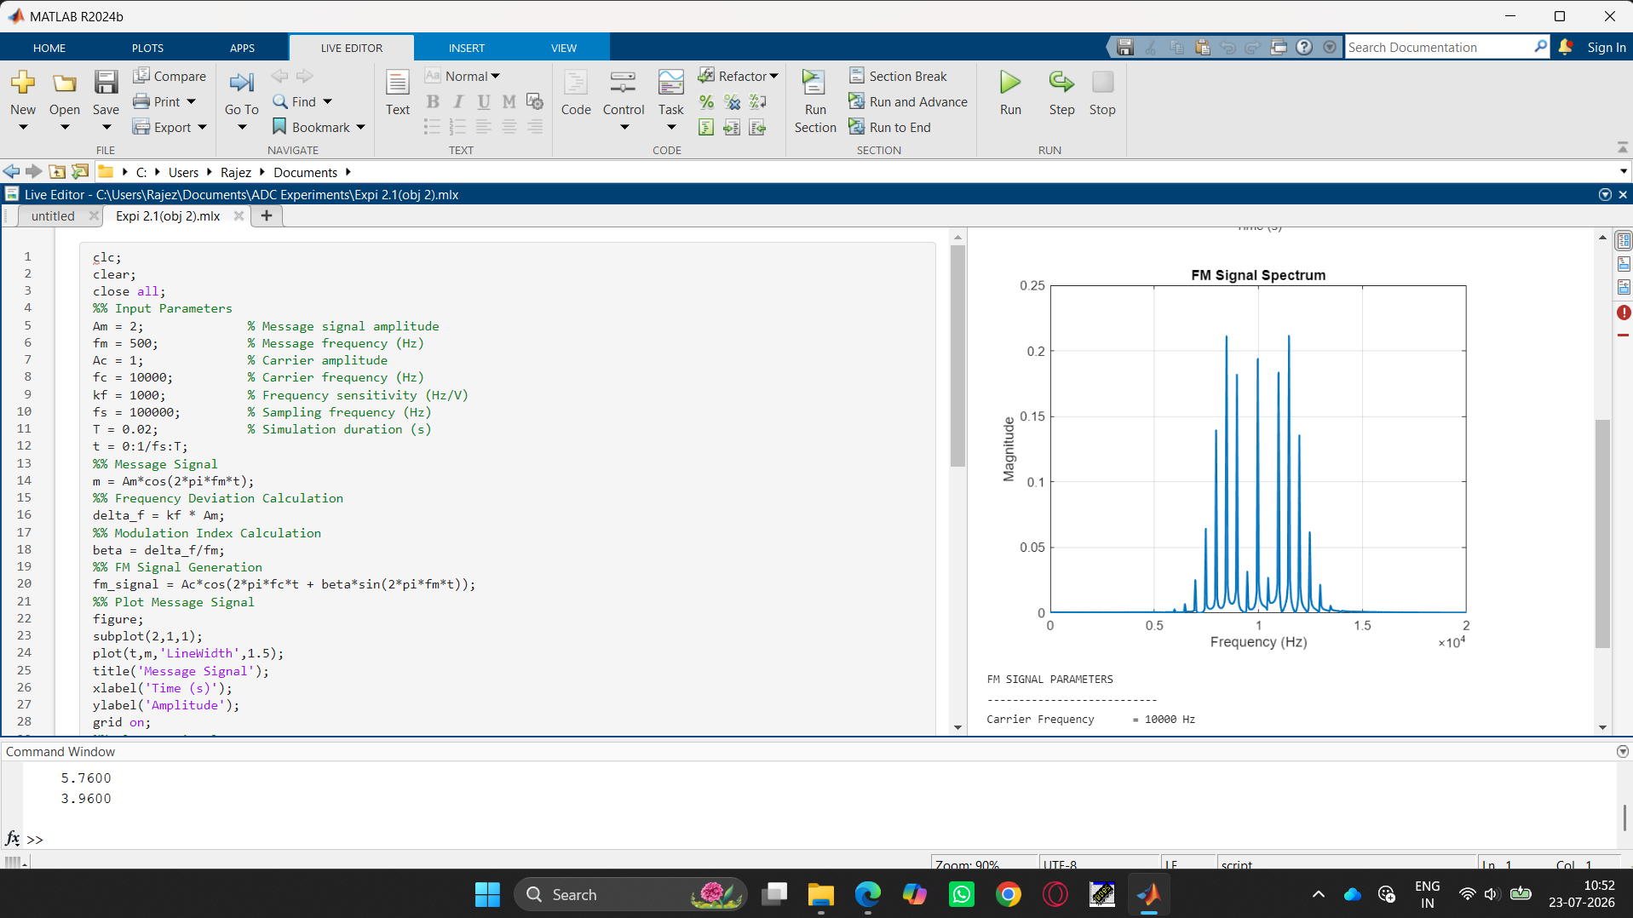

Result
i) The time-domain waveform was observed, and the frequency spectrum obtained using FFT has been plotted.
ii) Also, calculated the frequency deviation and bandwidth using Carson’s rule.

